**GIT INSTALLATION AND OPERATIONS**

**DEEPIKA VA**

**MCA-R**

**2014202010**

***Installation of GIT***

1.Removing yum lock in order to set the proxy

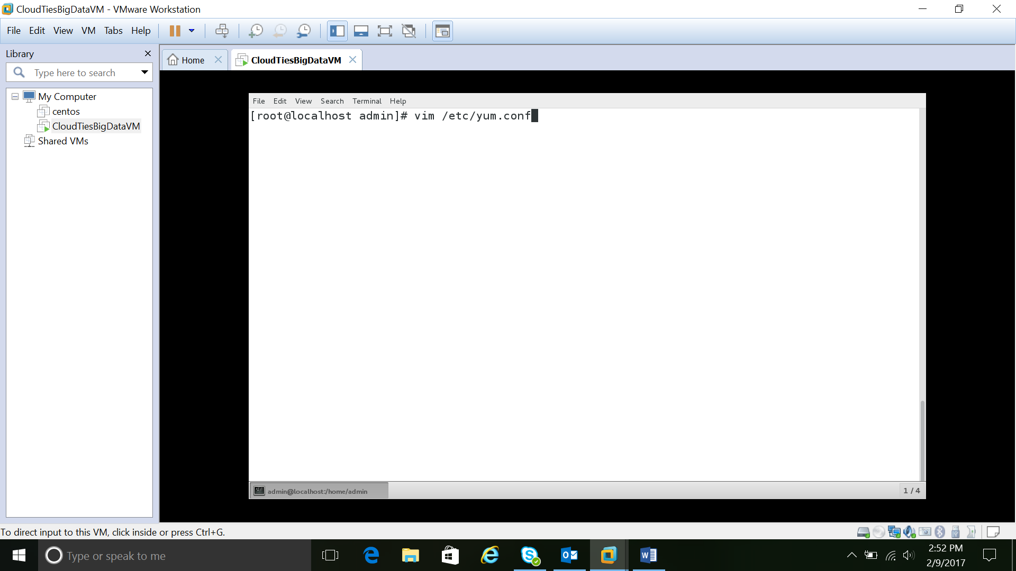

2.ADD : proxy=http://web-proxy.sgp.hpecorp.net:8080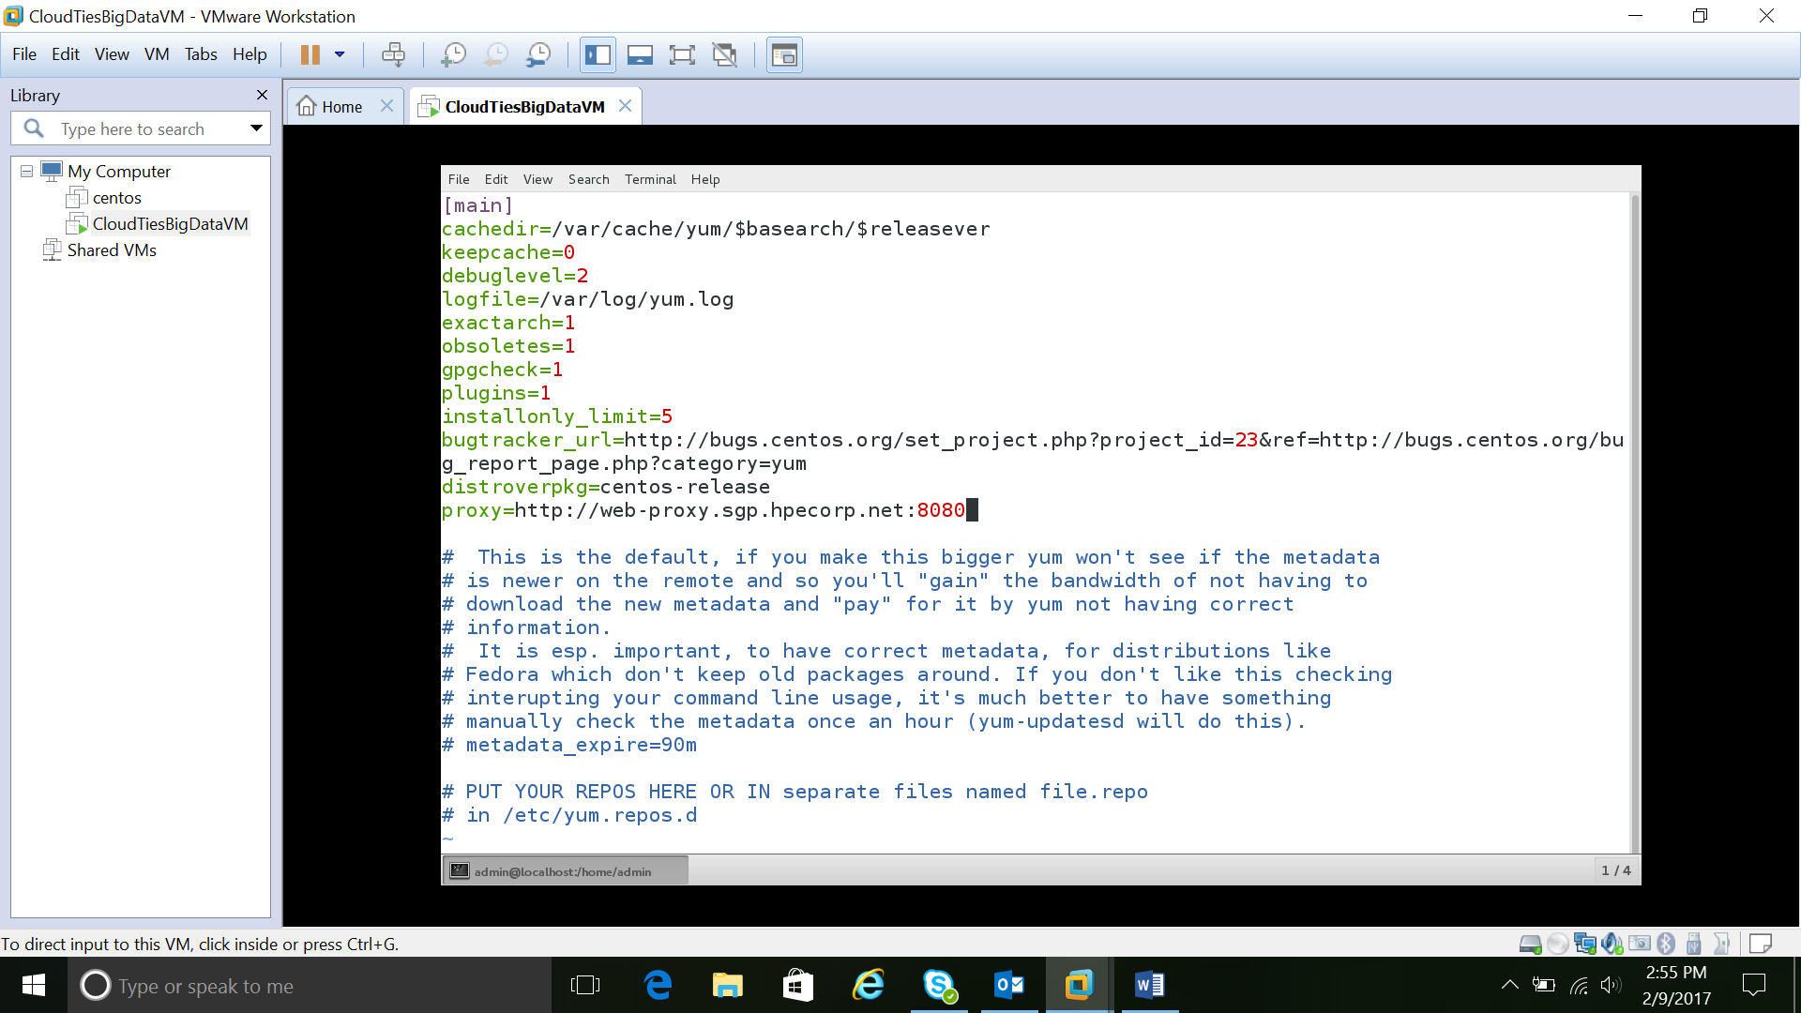

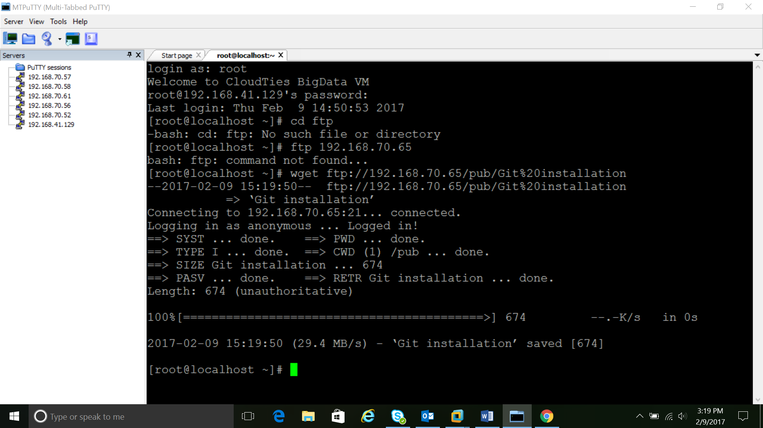

3. Check whether java is installed or not

4. Yum install curl curl-devel

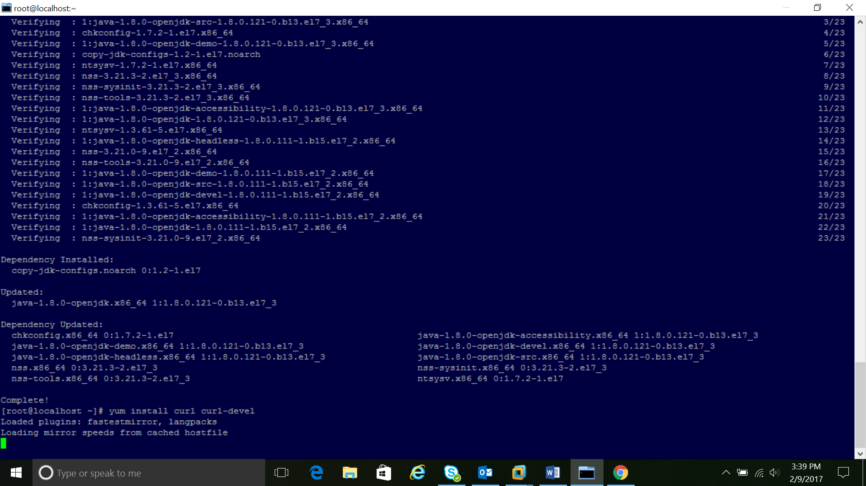

5.yum groupinstall "Development Tools"

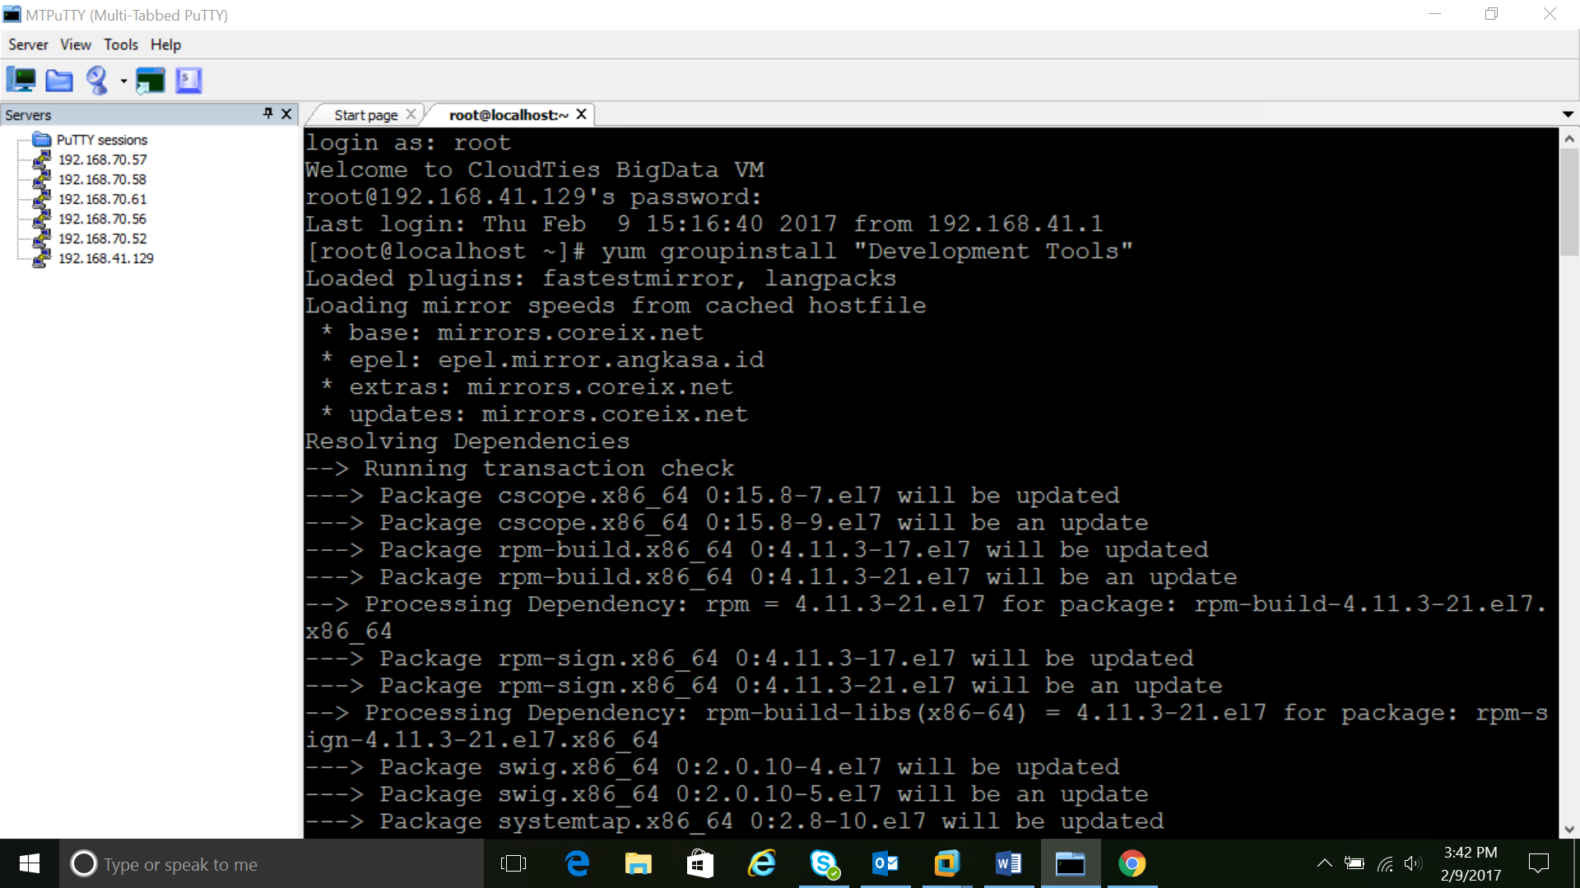

6.yum install gettext-devel openssl-devel perl-CPAN perl-devel zlib-devel

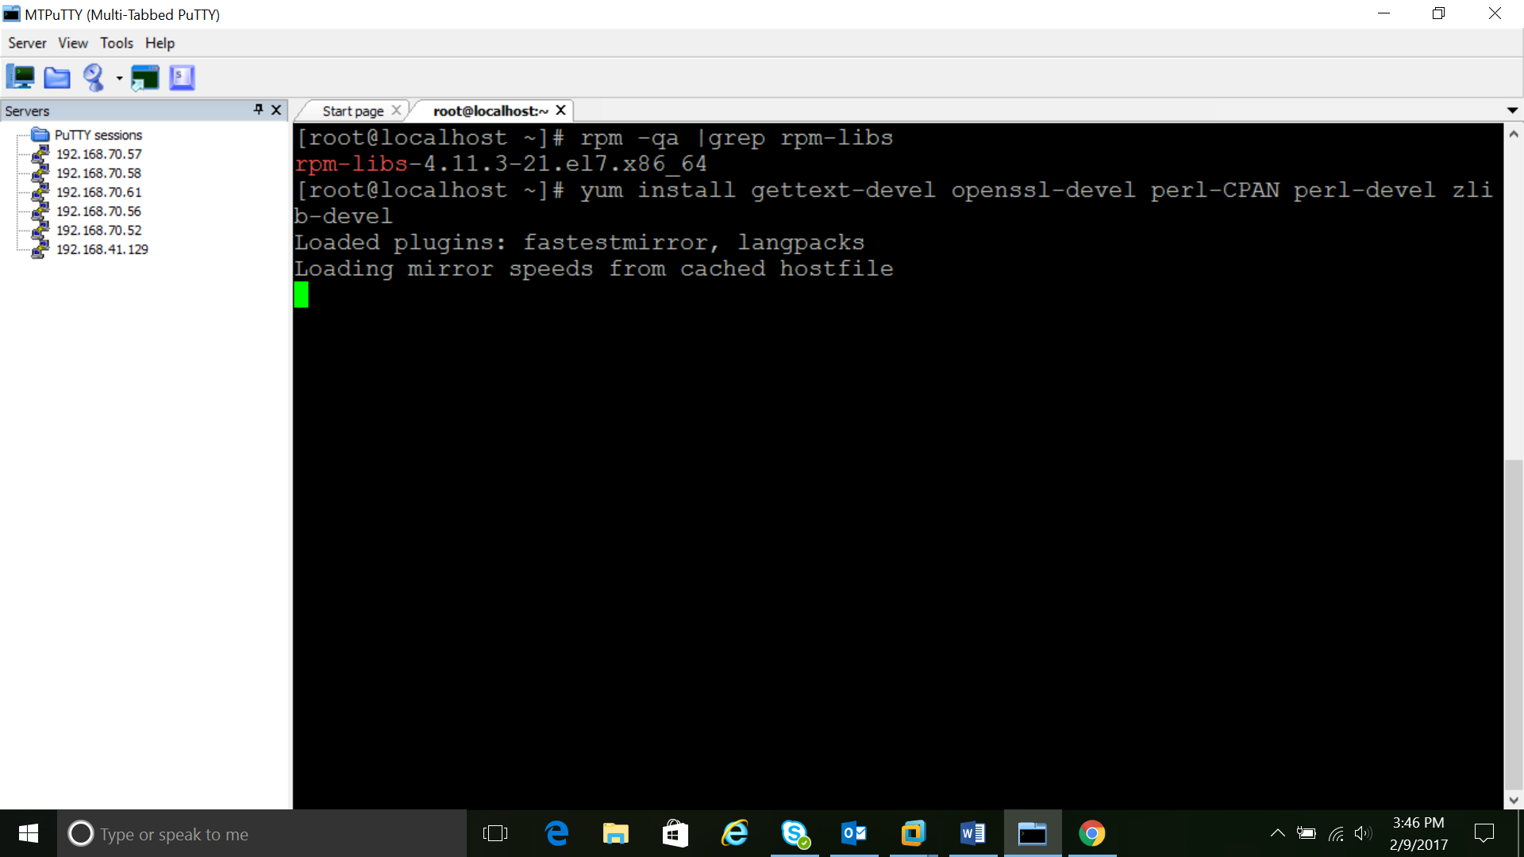

7.go to github page and download latest git source code

https://github.com/git/git/releases

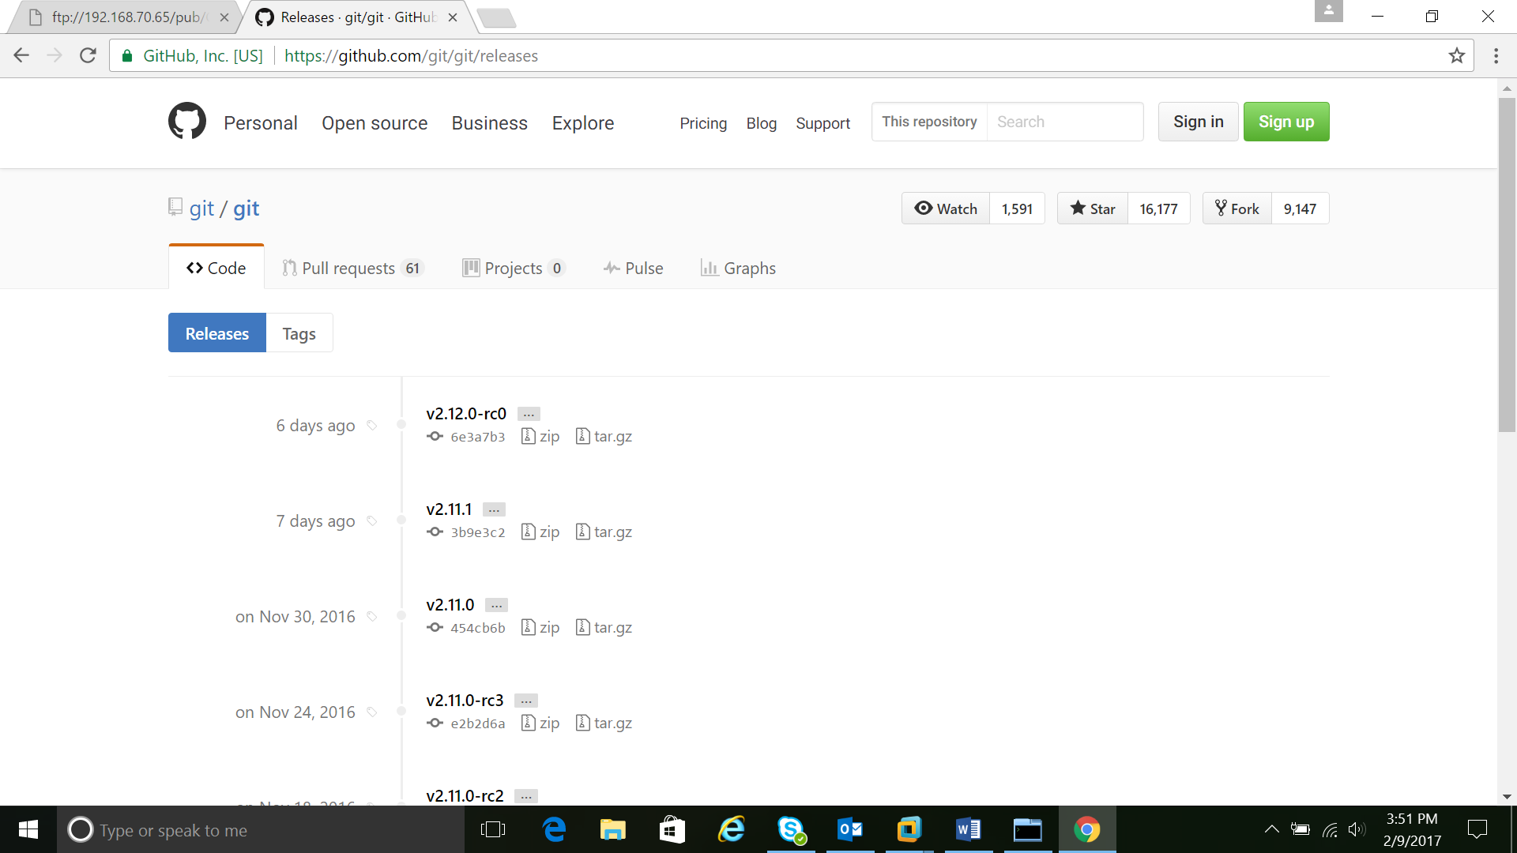

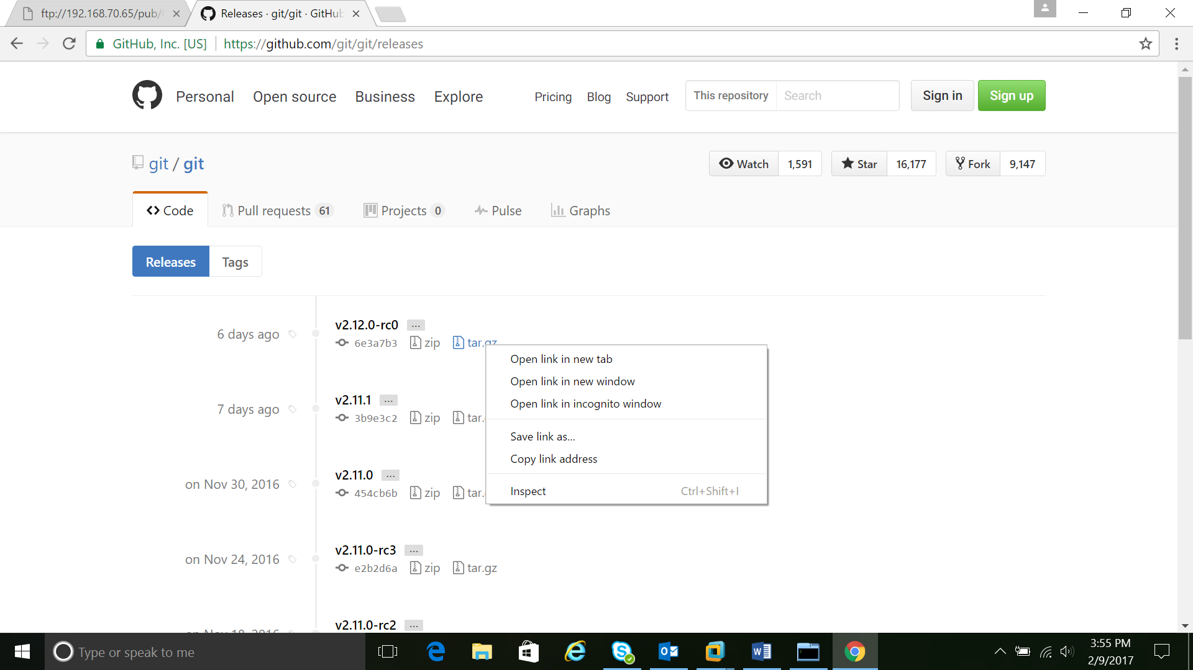

8.wget link

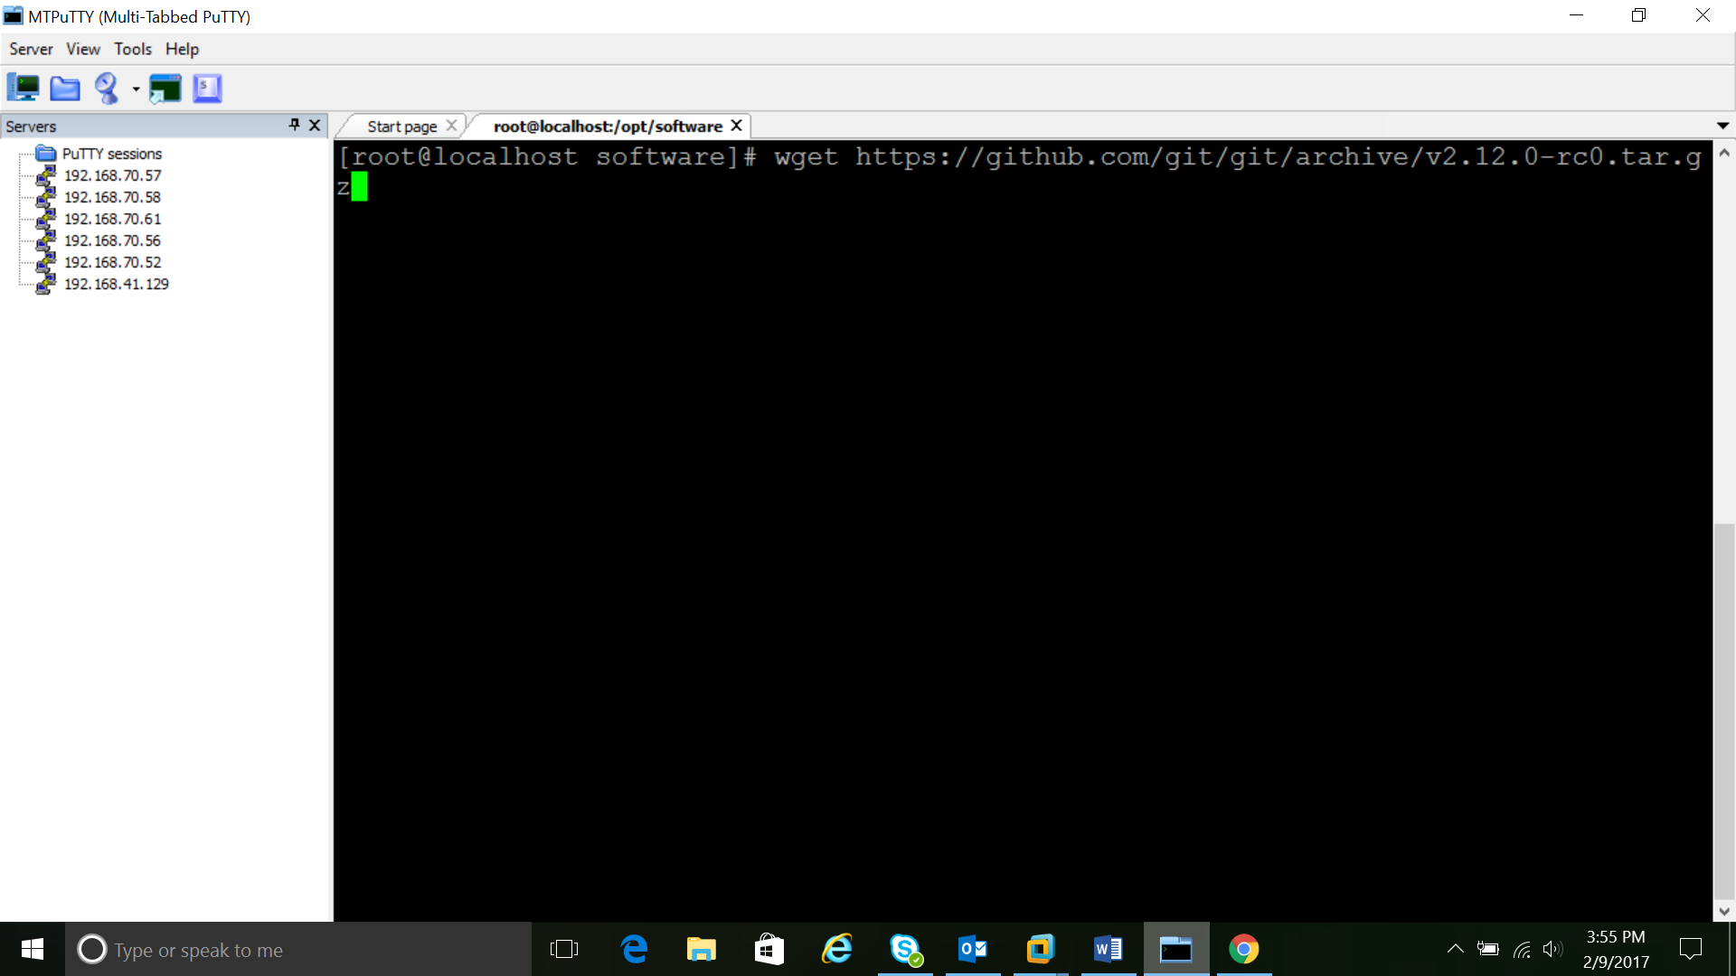

9.mv v2.12.0-rc0.tar.gz to /opt/software/.

10.rename the v2.12.0-rc0.tar.gz to git-2.12.tar.gz

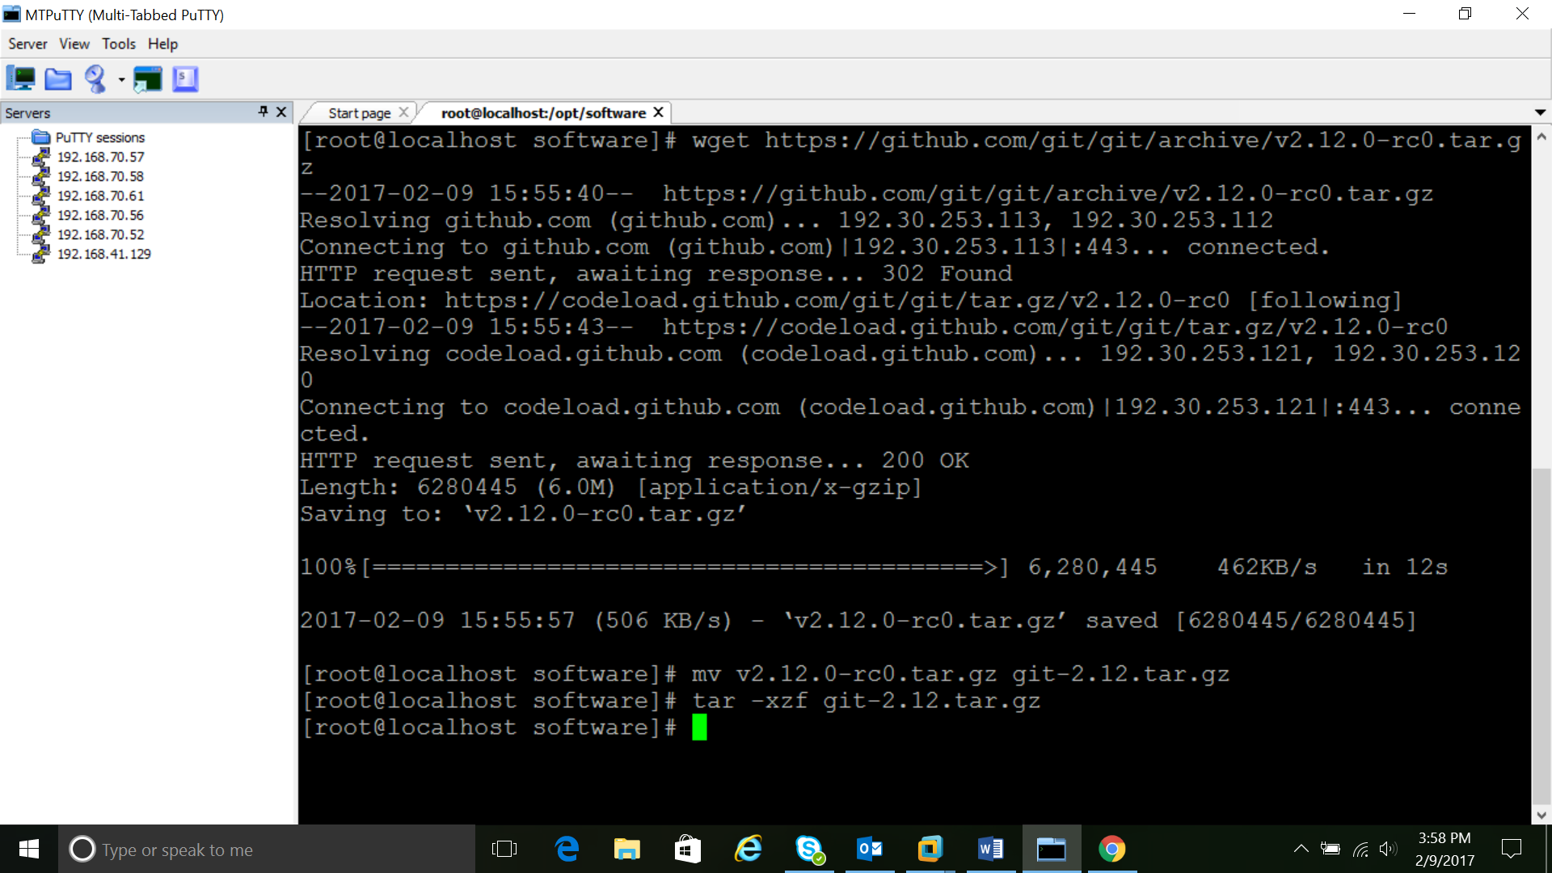

11.untar it using the command

tar -xzf git-2.12.tar.gz

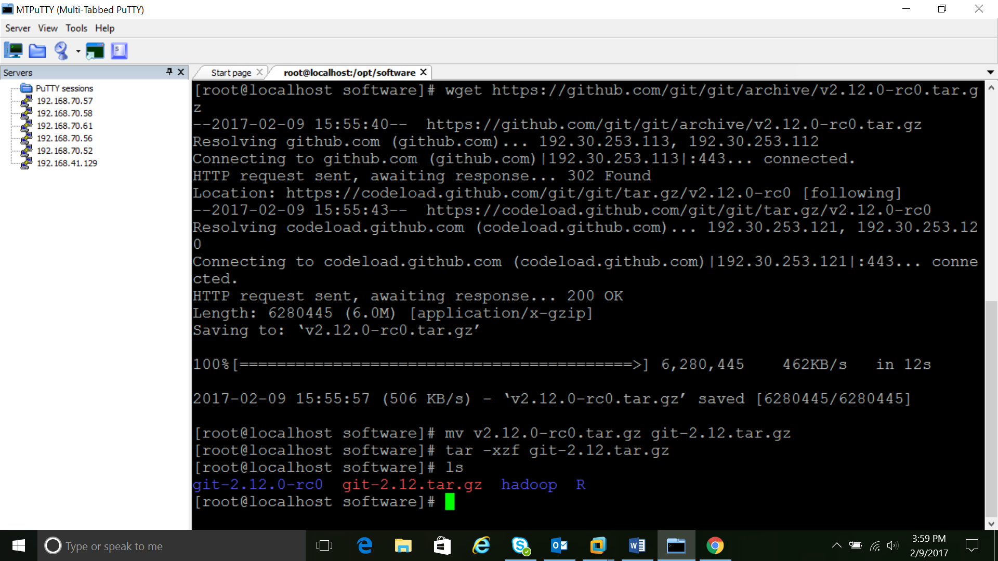

12.cd git-*

13.make configure

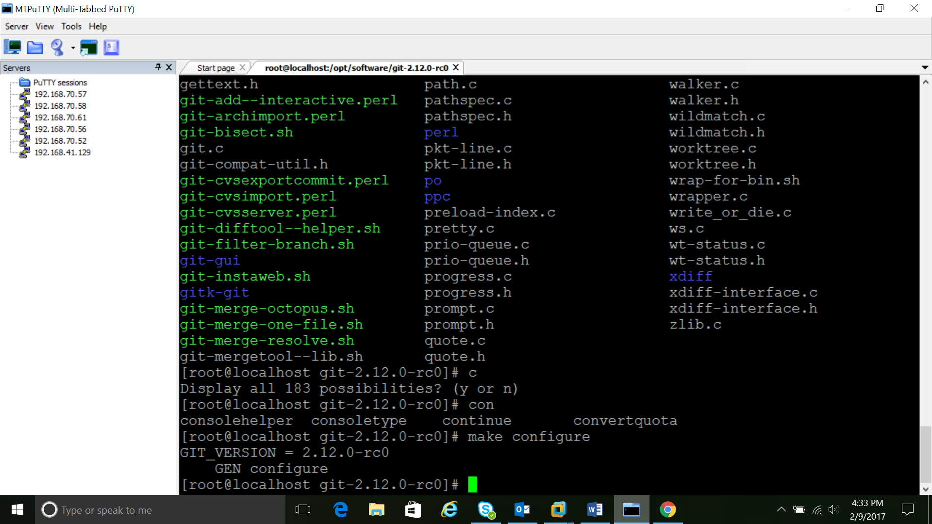

14.#make

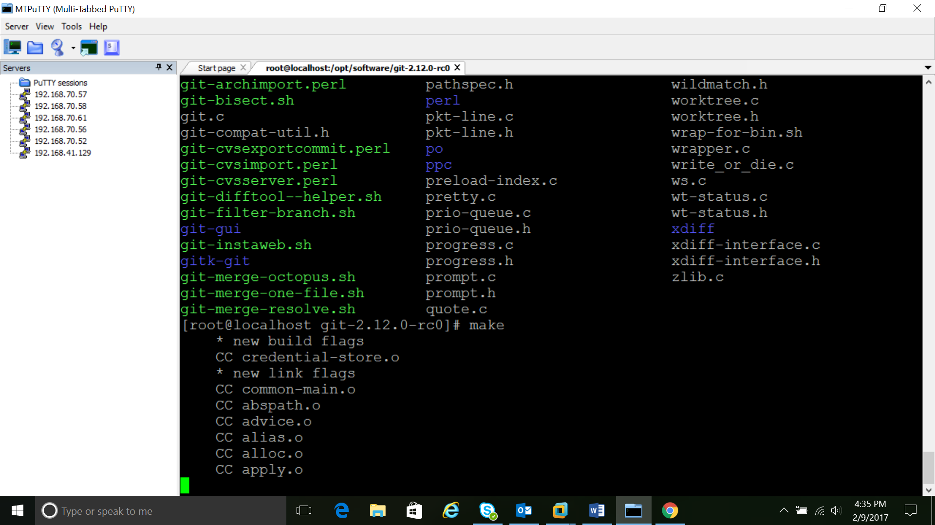

15 #./configure --prefix=/usr/local

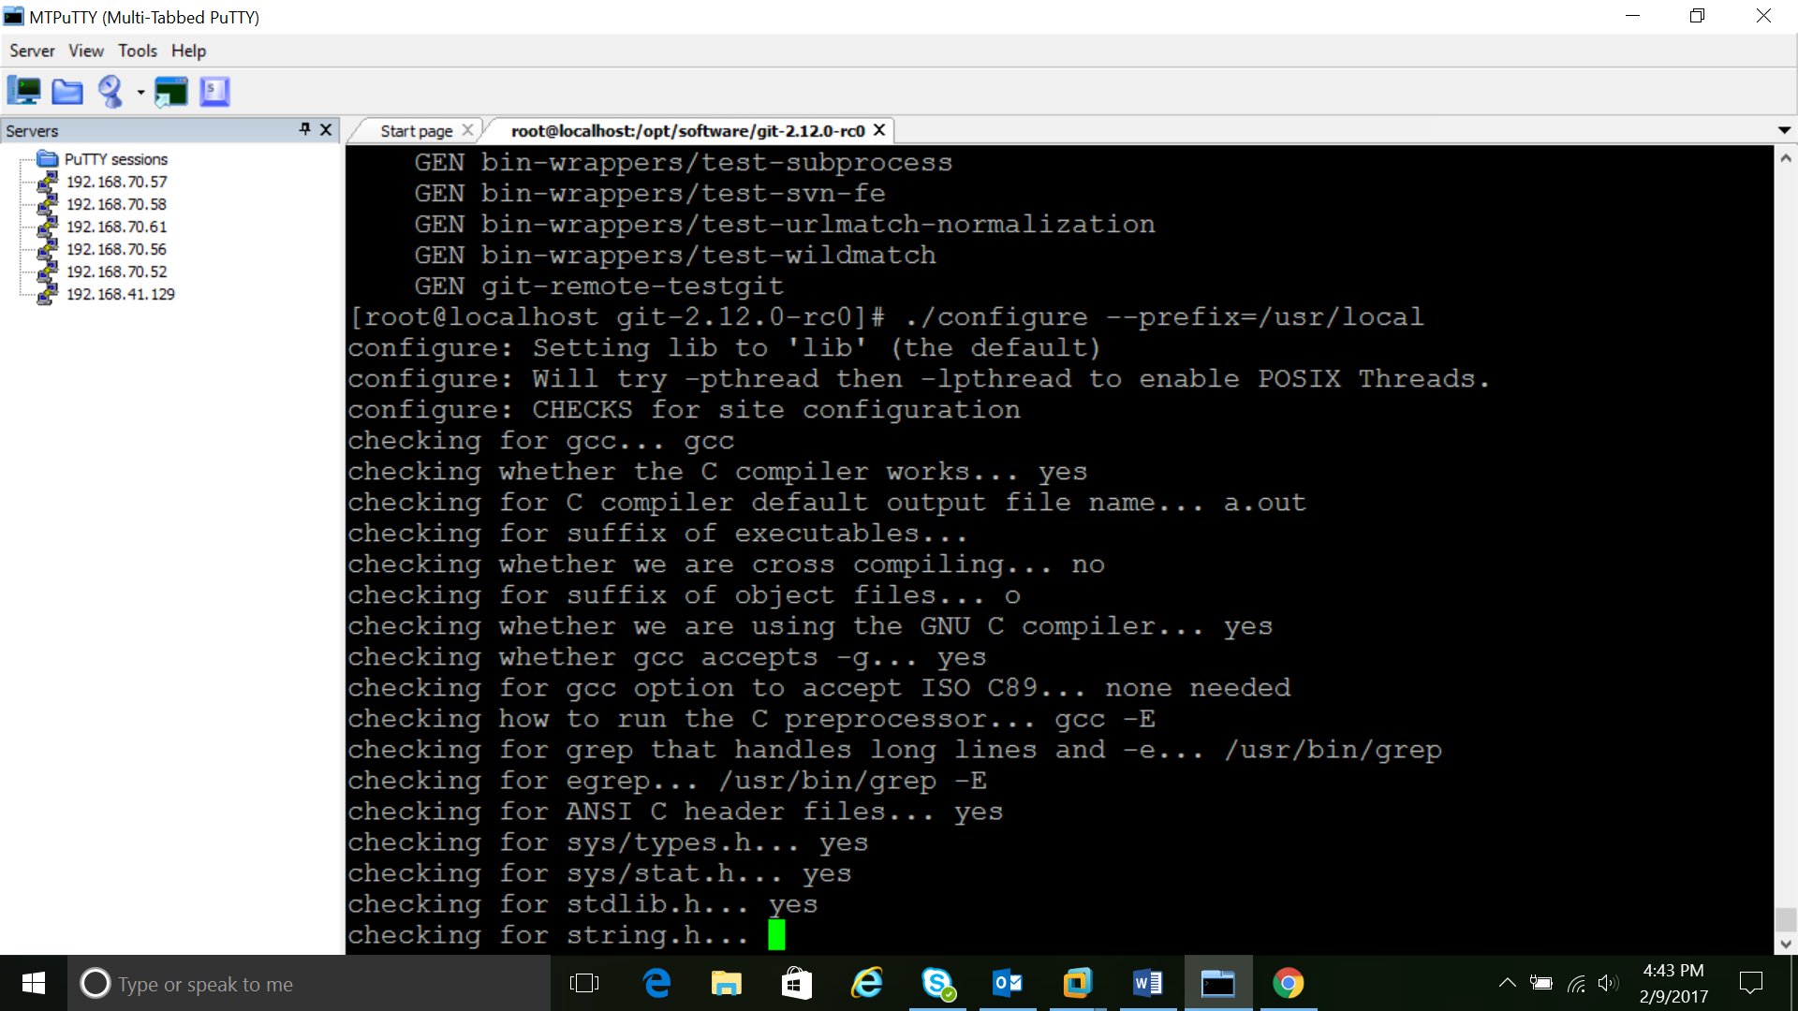

16.make install

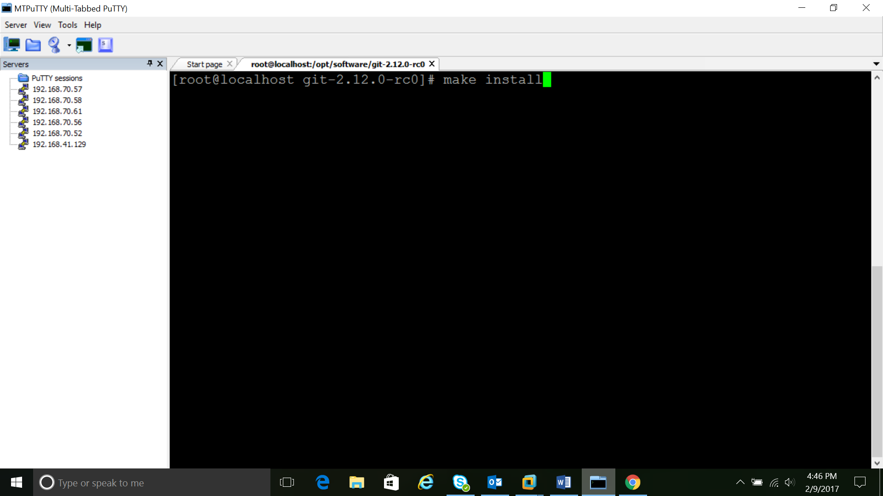

17.git --version

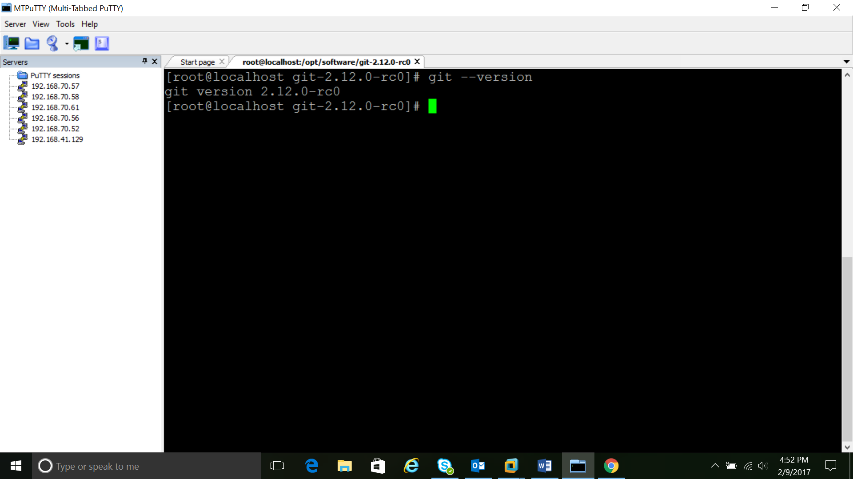

18.git config --global user.name "your Name"

19.git config --global user.mail "you@example.com"

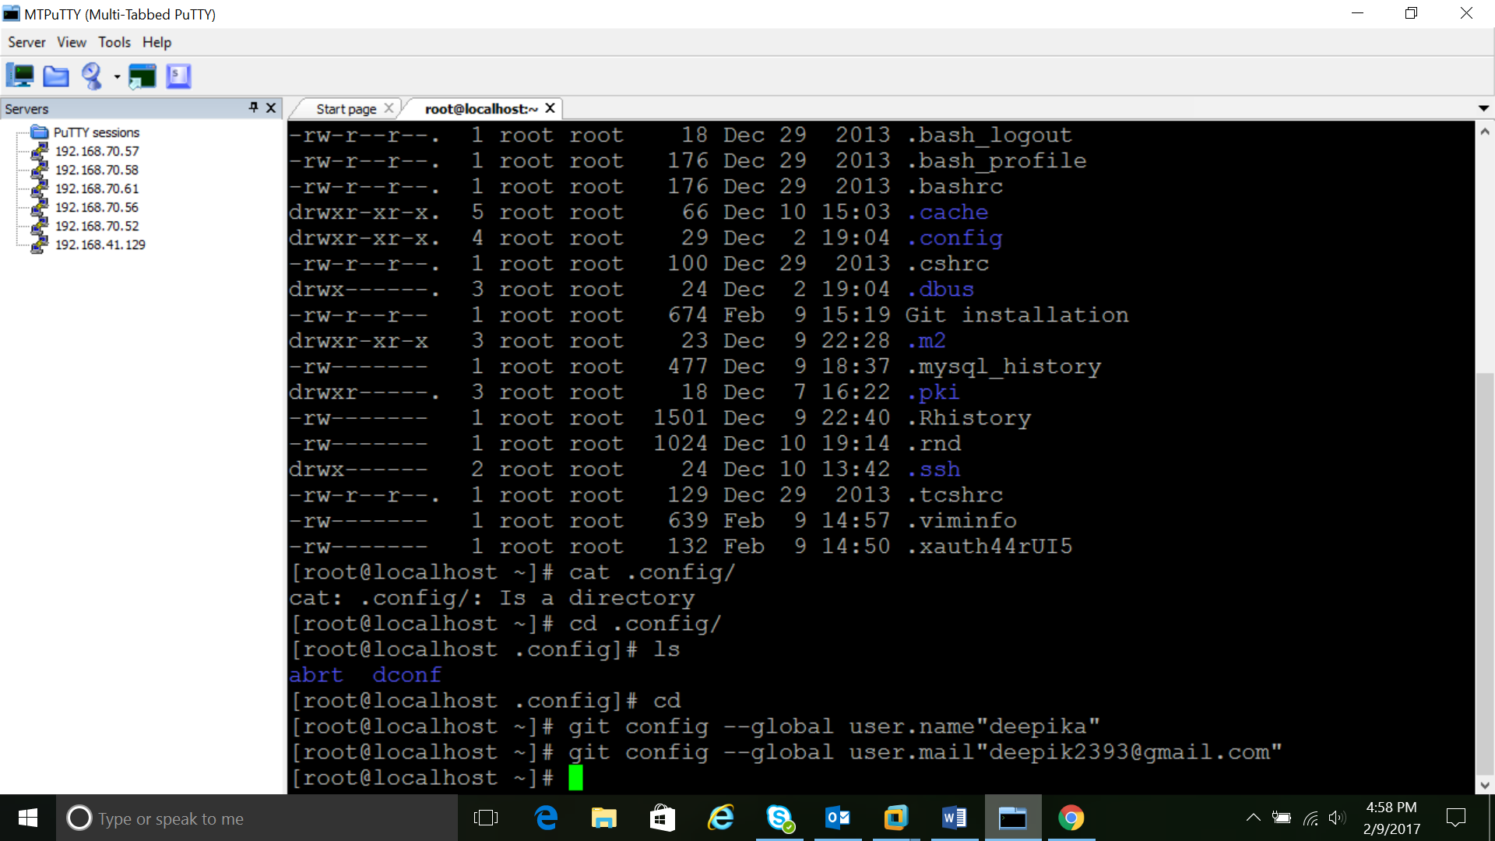

20.git config --list

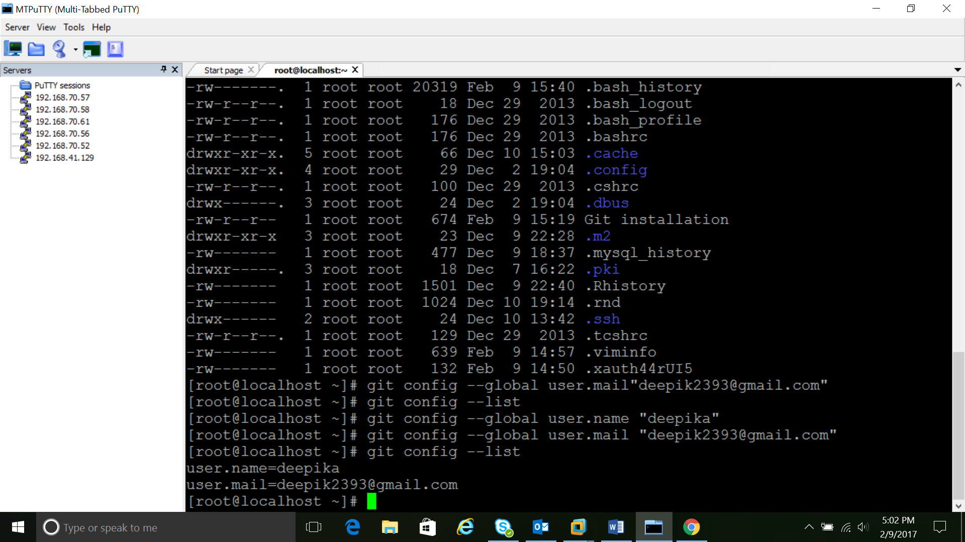

***OPERATIONS IN GIT***

Operations in git can be classified in to 4 basic operations

* Track
* Stage
* Commit
* Unstage

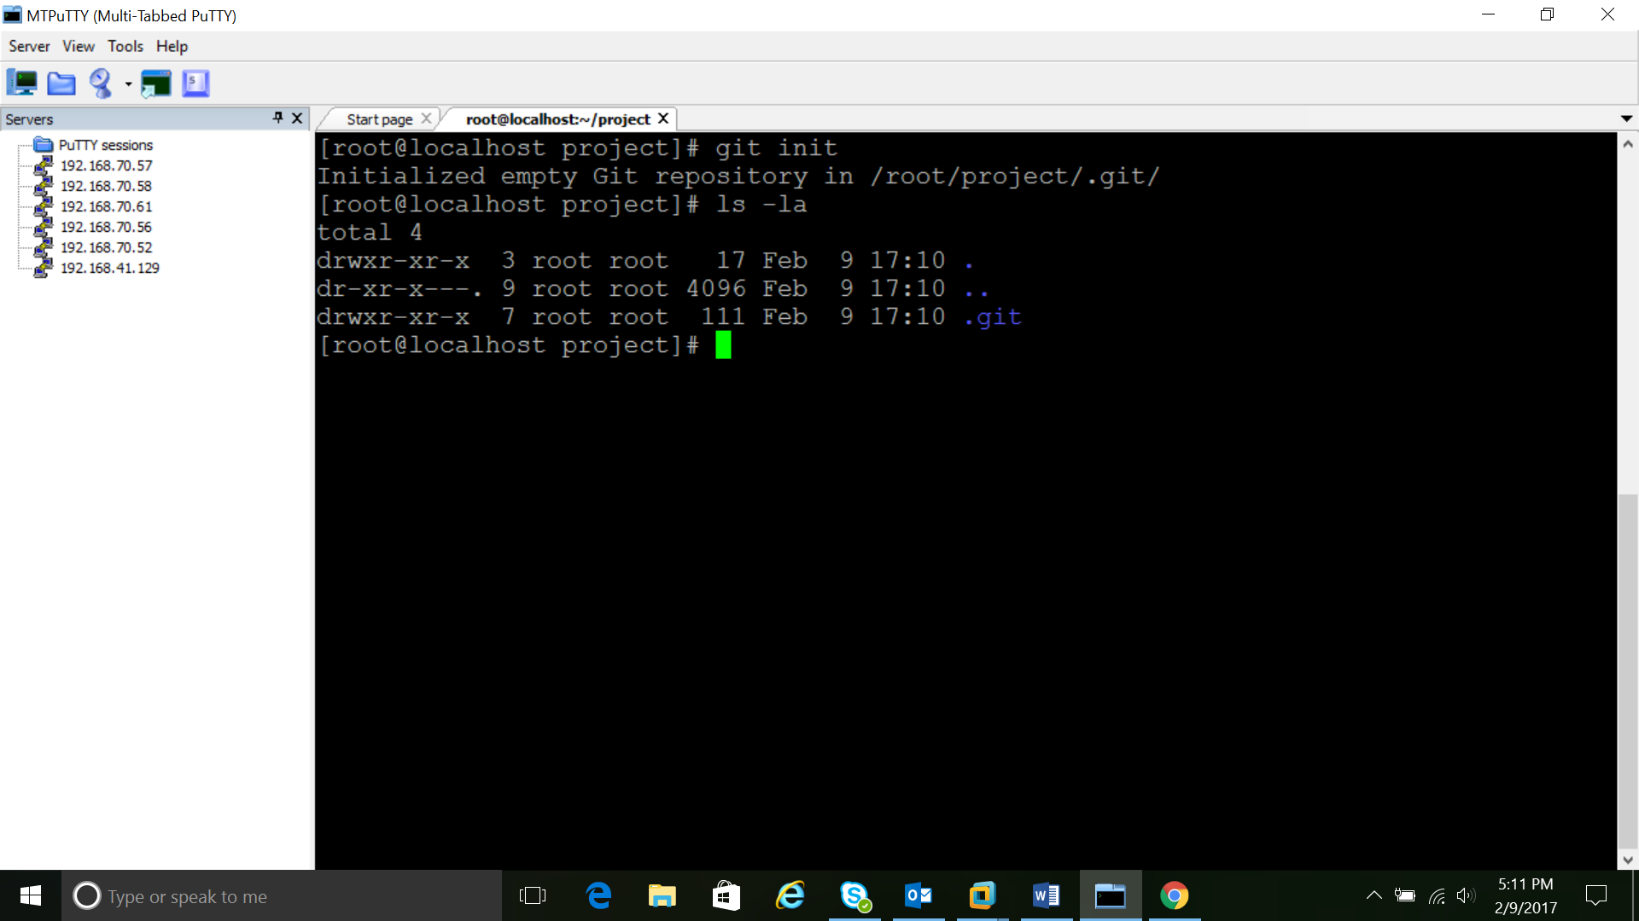

Making a folder in to a local repository by using the command **#git init**

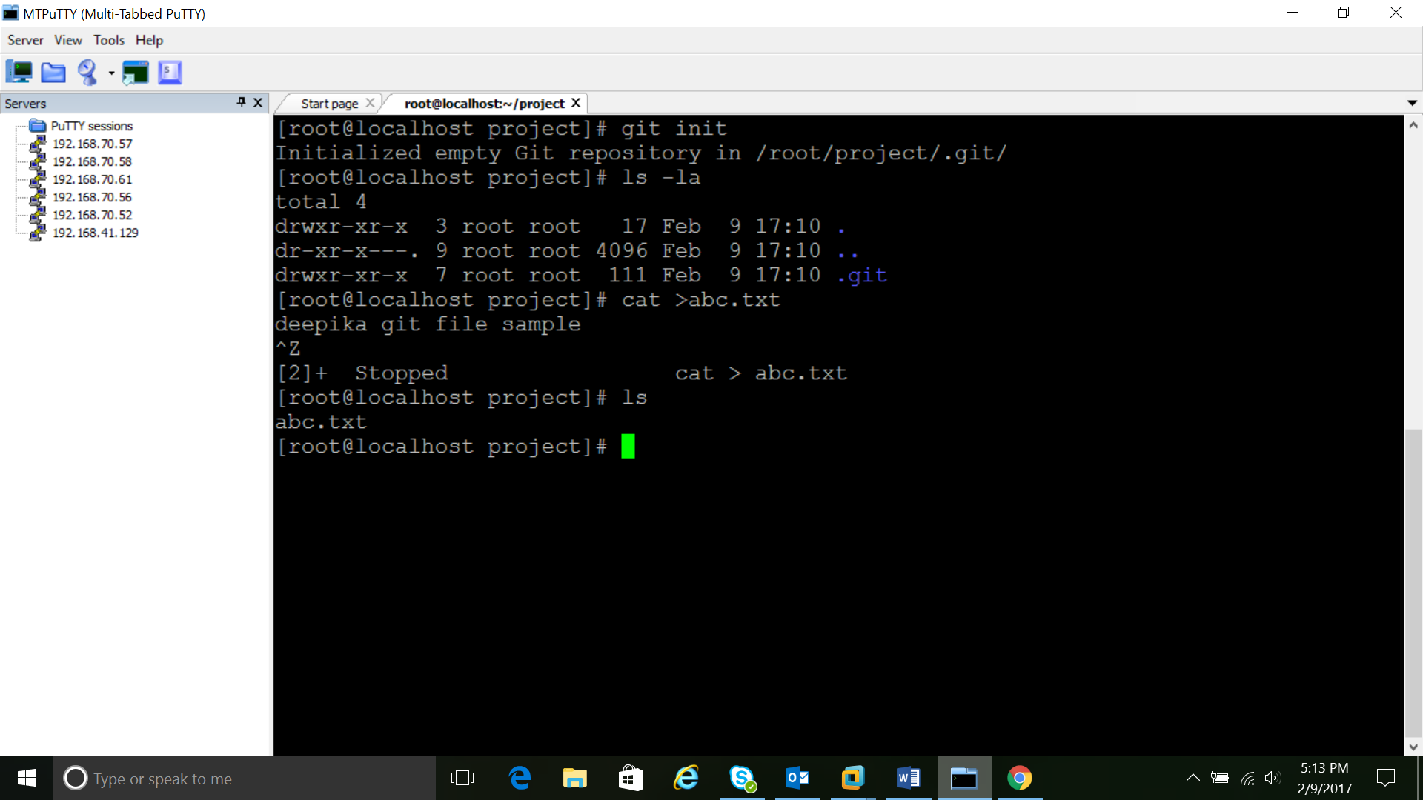

ADD

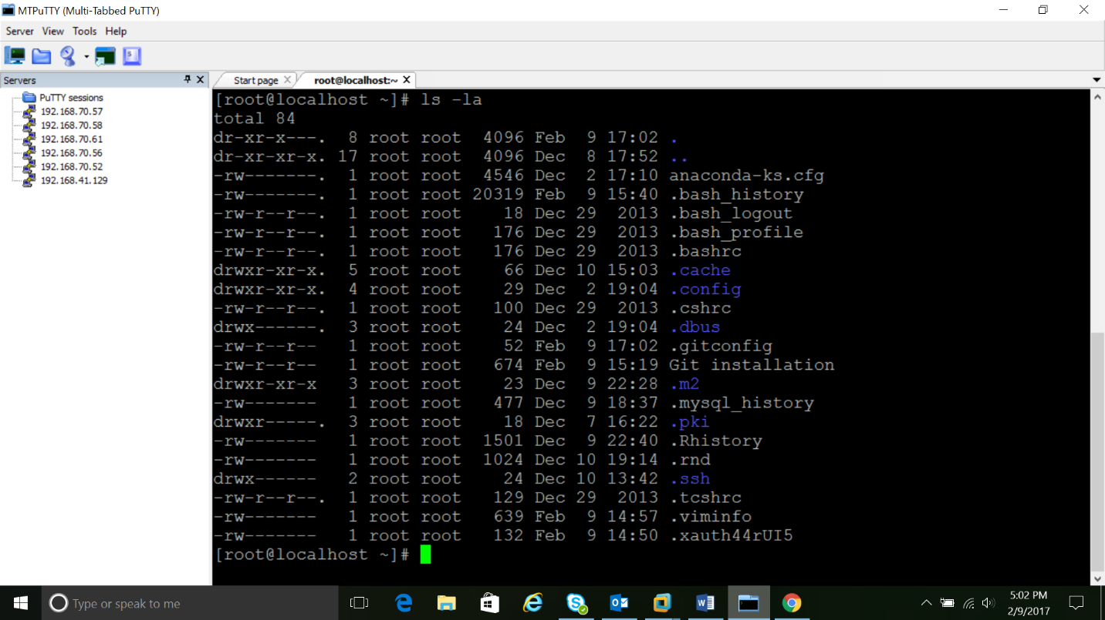  
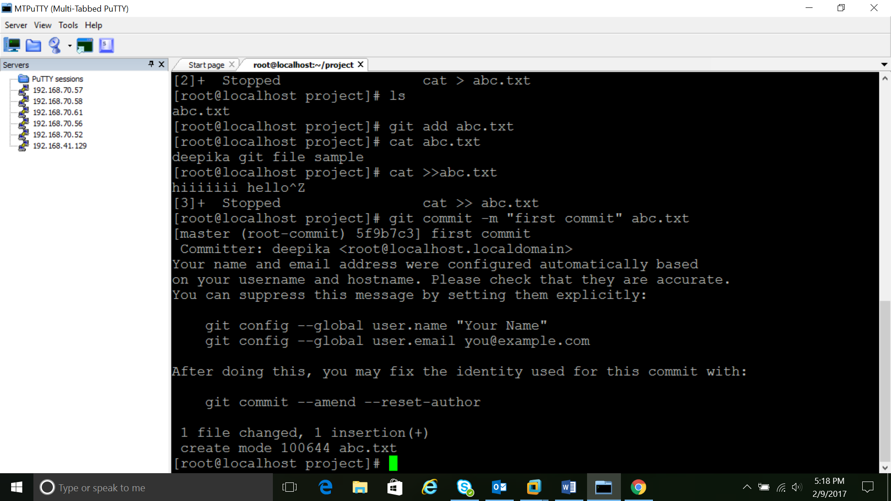

The file is being added and inserted in the git global repository #gid add filenme

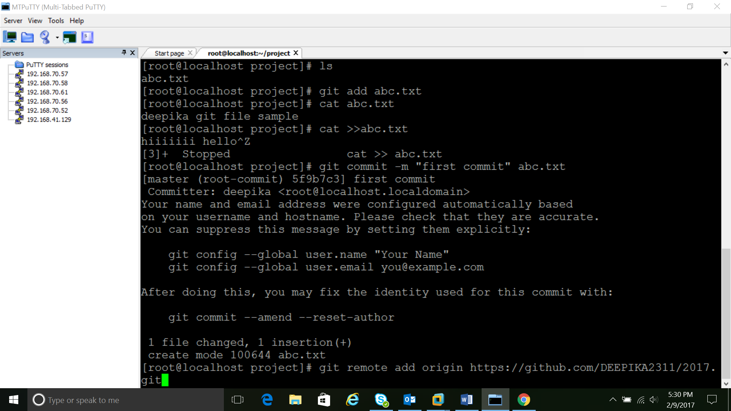

The file is commited using the comment #git commit –m “Commit message” filename

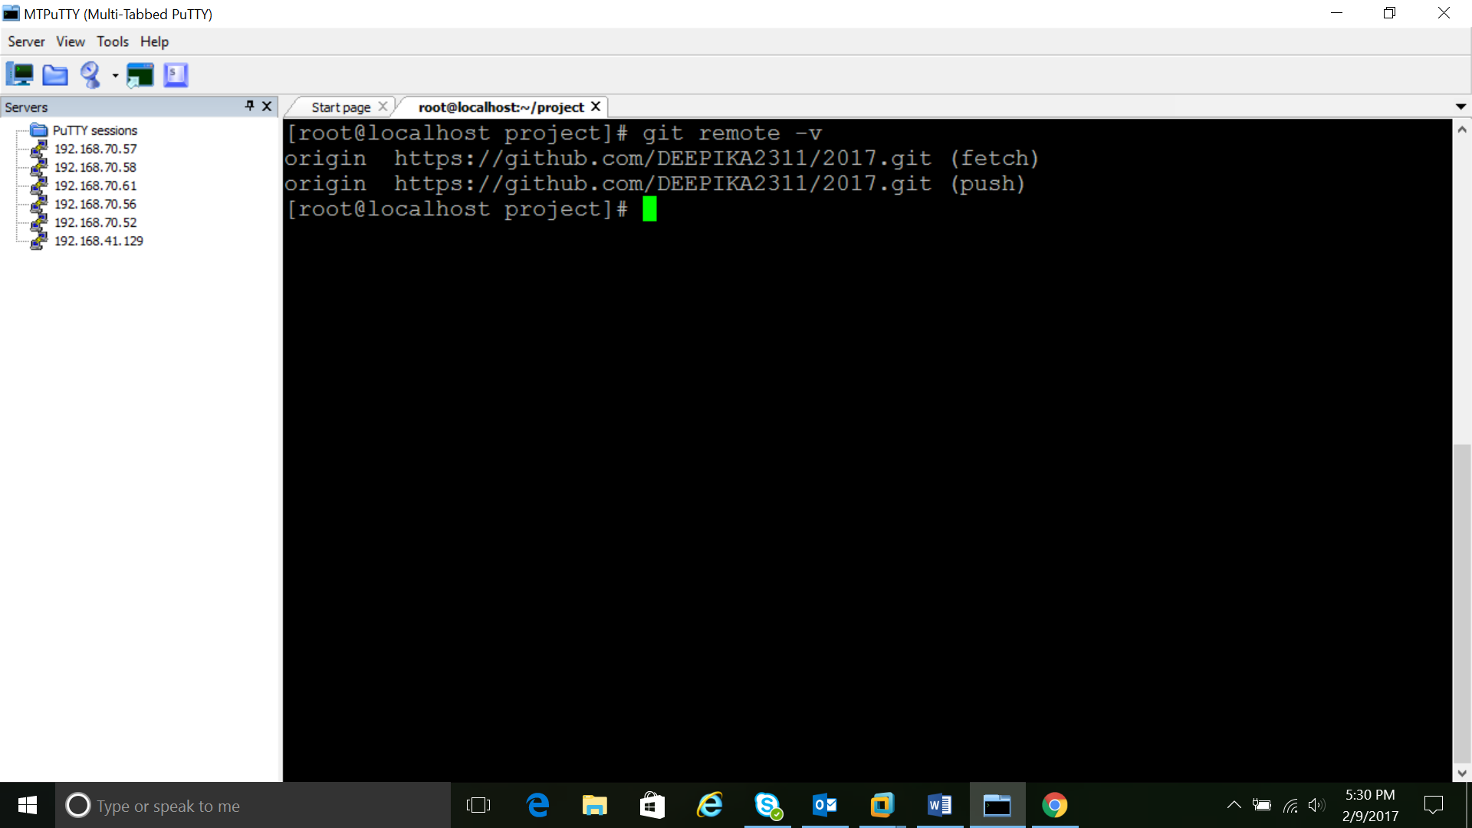

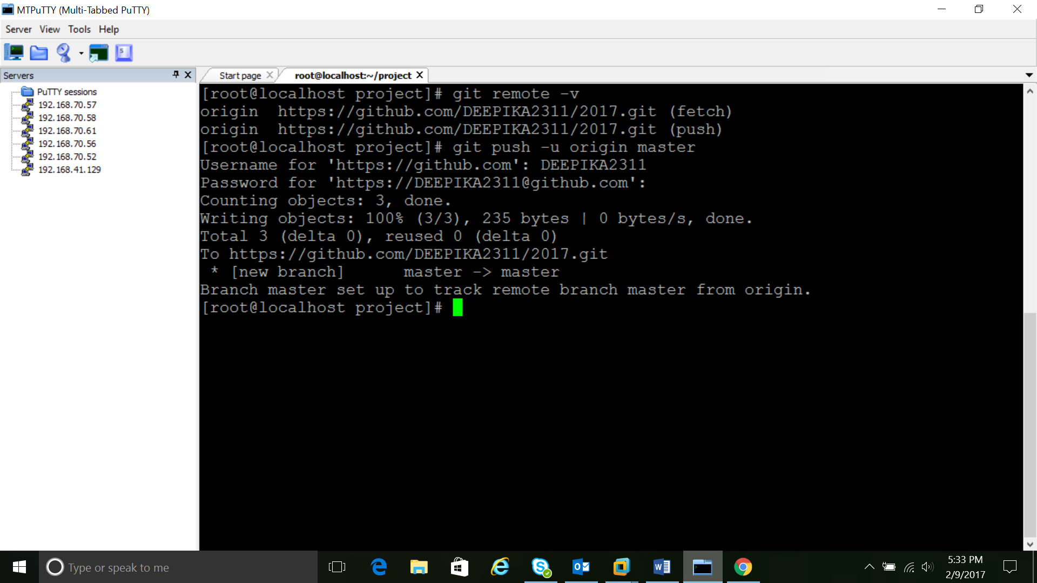

To add the file in global repository the following command has to be used

#git push –u origin master

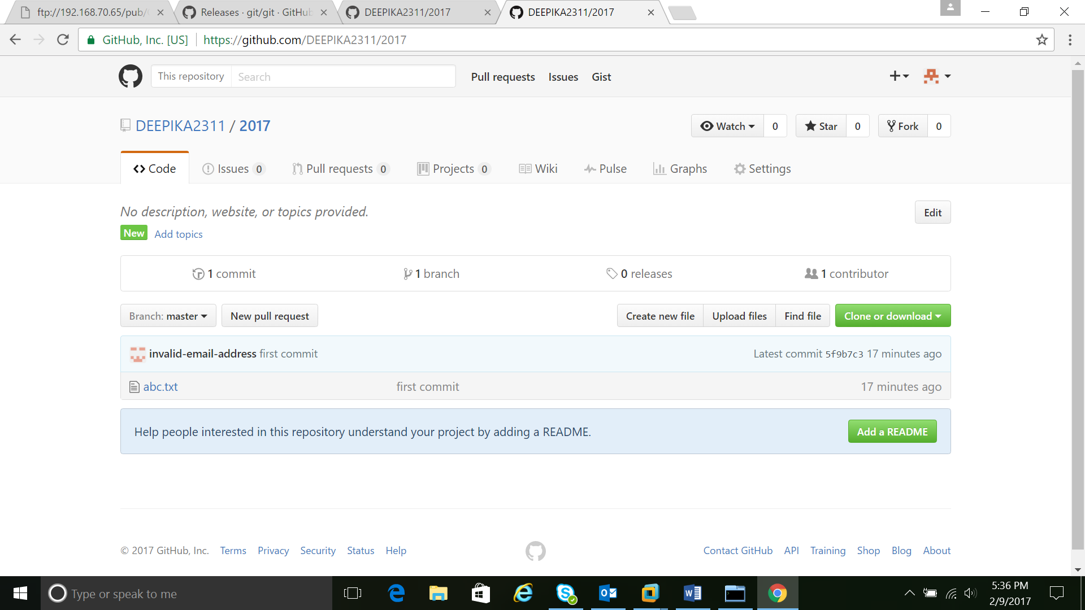

In order to see the log and commited Id

#git log

To find the difference between two logs

#git diff logId1 logID2

